What is PROHIBITED in the classroom?

- “Ditto” sheets-Sheets that the children only color
- Poisonous plants
- Tall Shelving with materials hanging over the edges
- Sharp edges
- Pop/Chips/Coffee, etc. in the classroom
  - Why? Is this setting a good, healthy example? Also, coffee is hot! What could happen? Instead: drink water to set a good example and it’s something a child can have.
- Purses not locked away
  - Why? If children have access to your purse, they have access to all of your meds and personal items. The children/adults in the classroom could trip on the strap or bag itself.
  - You will have visitors throughout the day, and you do not know their intentions. Someone may see your belongings and be tempted.
- Teaching staff/children walking barefoot in the classroom
- Cleaning with harmful materials while children are present
- Air Fresheners and scented deodorizers
  - Why? Strong fragrances from air fresheners and deodorizers can have adverse health effects on the health of children and adults including headaches, allergies, respiratory symptoms and the ability to concentrate.
  - Prohibited products include but are not limited to liquids, semisolids, solids, aerosol or pump sprays, wicks, wipes, diffusers, powers, crystals, designed or labeled for the purpose of masking odors or freshening, cleaning, scenting or deodorizing the air.

What “Ditto” Sheets do not do:
- They do not allow children to be creative or extend their thinking process.
- Do not allow use of all of the five senses: smell, touch, see, hear, and/or taste
- EXAMPLE: Apple “ditto” sheet vs. real apples

How do I know if a plant is poisonous or not?
- Use your computer/encyclopedia to look up the type of plant to ensure it’s not poisonous
- Use the barcode that can be found in the pot of plants. This can be scanned to see if the plant is non-poisonous.
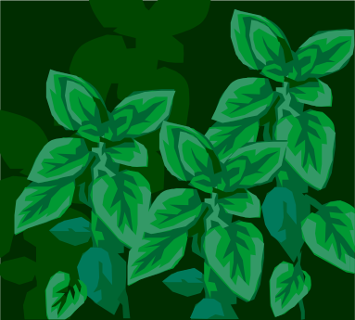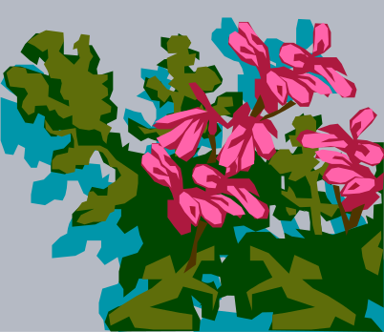

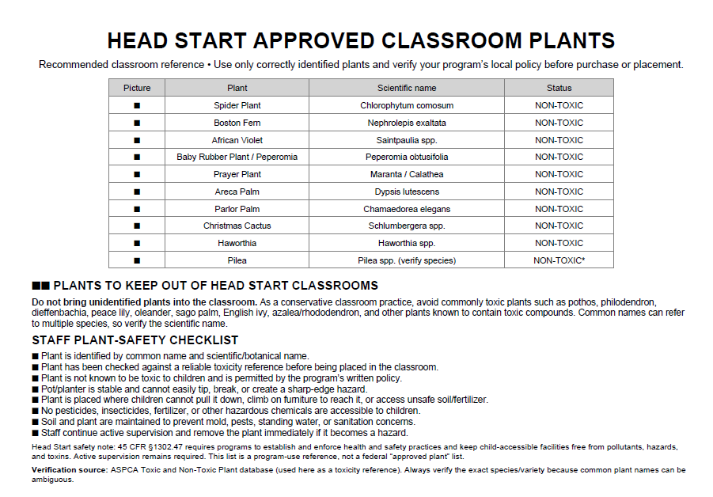
Shelving should be:
- Short enough to be able to get a visual on ALL areas of the classroom.
- Not so full of materials that children have a problem getting what they want out.
- Free of materials hanging over the top of the shelf to cause an injury to the children attempting to get materials out of the shelves.

SHARP EDGES CAN BE FOUND EVERYWHERE!
- Shelving
- Toys
- Bathroom
- Desks
- Chairs
- Playground
- Cubbies
- Any Center/Anytime
You, as the Teacher/Teacher Assistant, have to be the one to look to find these sharp edges before your children do!

What can happen if we are barefoot in the classroom?
- Spreading of germs/diseases
- Unsanitary
- Bump, cut, or damage toes/feet
- What about during fire and tornado drills? These are usually unexpected.
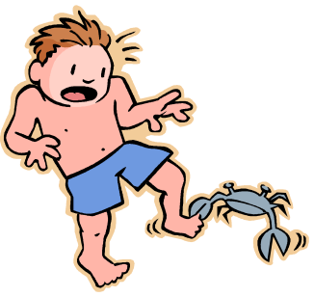

Cleaning while children are present:
- Use damp paper towels, cleaning cloths, or wipes
- Tables must air dry or be dried by a paper towel before children can be seated.
- Only clean small spills with paper towels…. save mopping until children are out of the area.
Cleaning while children aren’t present:
- Remember: It must be an EPA-approved product AND follow the directions listed by that manufacturer. Should be posted on the label if it’s EPA approved.

