Mental Health
Mental Health Schedule
- Ensure your Mental Health schedule is posted on your parent board.
Mental Health Referrals
If a child needs a mental health referral, please contact the Mental Health Services Manager. All referrals must include the following:
- Completed referral form
- Record of observations/ reason for submitting referral in Family Case Notes.
- Permission for Mental Health Services form signed by the parent
- Permission to Release Information form during home visits or other contacts, parents may also request mental health services. In these instances, the staff person should generate a referral and document the reasons provided by the parent for requesting mental health services.
The required paperwork can be found on the Big Sandy Head Start website and includes:
- Acknowledgement of Privacy Practices
- Authorization for Release of Health Information
- Consent Form
Please be sure to provide the parent/guardian with a copy of the Acknowledgement of Privacy Practices.
Once all required paperwork is received, the Mental Health Services Manager will contact a Mental Health Consultant. Within one week, the Mental Health Services Manager will follow up with the teacher to confirm whether an observation has been scheduled.
Mental Health Consultant Classroom Observations
If a Mental Health Consultant comes to your classroom, please email the Mental Health Services Manager with:
- The name of the consultant
- The amount of time spent in your classroom
Declined Mental Health Services
If a parent/guardian declines mental health services, it is recommended to obtain their signature on the Refusal for Consent to Mental Health Services form.
- If the parent does not sign, document this in COPA under Family Case Notes and send the information to the Mental Health Services Manager.
- Staff will continue working with the family, and alternative strategies will be determined.

Follow-Up Recommendations
Once an observation report is received, it is the responsibility of teachers, directors, and/or principals, to follow up on any recommendations provided by the Mental Health Consultant at Mountain Comprehensive Care Center (MCCC).
For example, if school-based therapy is recommended, staff can contact MCCC to schedule an intake. When doing so, please provide the child’s information, the name of the mental health consultant, and a brief summary of the findings.
It is essential to document notable behavioral concerns in COPA under Family Case Notes. Documentation should include any significant behavior concerns, such as physical aggression, in addition to atypical behaviors. This documentation supports teachers and staff when advocating for children who may need services, referrals, or additional support.
Family case notes should clearly reflect the progression of referrals from initiation through completion. A monthly case note is required in the following situations:
- When a referral is made for mental health services
- When notable behavioral incidents occur, including physical aggression
If you have questions regarding behavioral concerns or available resources, please contact the Mental Health Services Manager for guidance. Attached are the step-by-step instructions for documenting mental health case notes in COPA.

Instructions for Entering Family Case Notes
- First, find the child you wish to document for under “Child Search.”
- On the Child Data Sheet, find “family information” in the upper right corner as shown below.

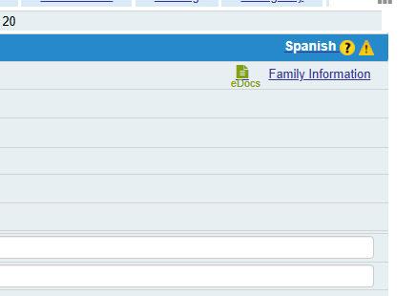

- Next, click the “Case Notes” tab as shown below.
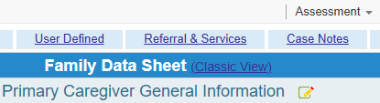

- Click the pencil icon beside the words “Family Case Notes.”

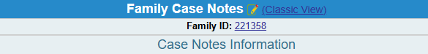

- Select the “category” as shown below. For the notes mentioned this should be Mental Health.
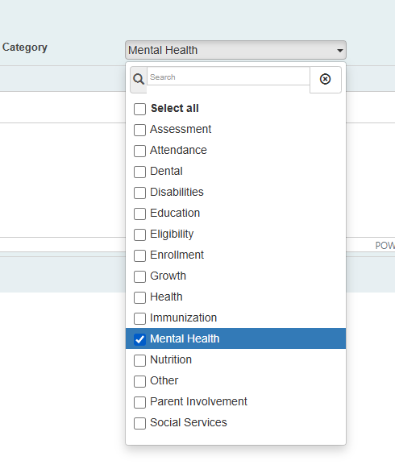
- Below is an example of a note regarding a behavior event.
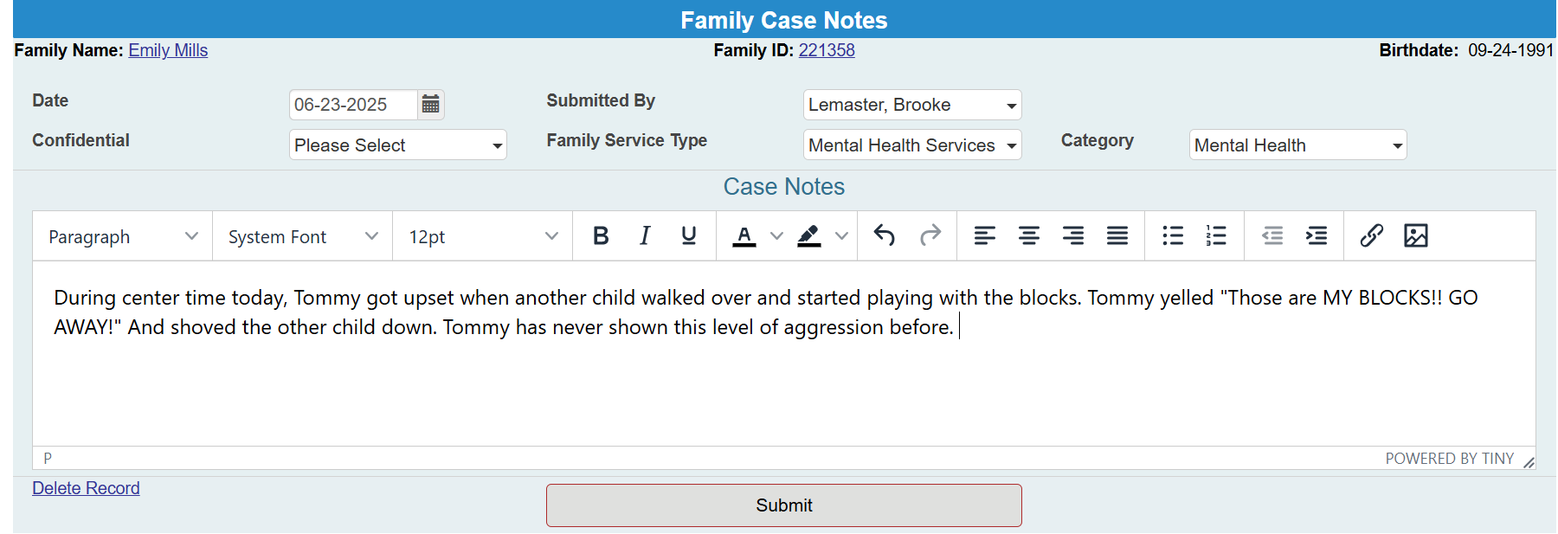

- When finished click “submit.”

RTI: Social Emotional and Self-Help
If a child scores below average in Social Emotional and/or Self-Help on the Brigance screening, a rescreen would need to be completed in 30 days. If the child scores below average on rescreen, the child must receive additional support through the Response to Intervention (RTI) process and be included in the RTI delegate report.

Screening and Initial RTI Placement
This information must be documented in COPA under the Developmental tab, including:
- Screening date
- Child’s age at screening
- Person who conducted the screening
- Instrument used (Brigance)
- Result (below age level)
- Decision to rescreen in 30 days
- Decision on RTI placement

Documenting RTI in COPA
Progress monitoring for all RTI tiers must be documented in COPA under the Developmental tab. A monthly RTI progress note is required for each child, summarizing progress made or identifying continued areas of concern.
If a child demonstrates adequate progress, the teacher may move the child to a lower RTI tier or remove the child from RTI entirely. While rescreening is not required to remove a child from RTI, it is strongly recommended to confirm the child’s progress.

Second Step
The Second Step Early Learning program is designed to help educators guide children in learning, practicing, and applying skills for self-regulation and social-emotional competence. The program is organized into five units delivered over a 28-week period. The first four units focus on developing skills related to Empathy, Emotion Management, Friendship Skills, and Problem Solving. The fifth unit, Transitioning to Kindergarten, reviews concepts from the previous units and supports children in applying these skills as they prepare for kindergarten.
Use of the Second Step curriculum must be listed as a stand-alone activity on the daily schedule for a minimum of 10 minutes. Although the program is designed to span 28 weeks, the remaining weeks of the school year provide valuable opportunities to reinforce and deepen children’s understanding of key social-emotional concepts. Educators are encouraged to revisit foundational themes such as Identifying Feelings, Managing Feelings, Empathy, Fair Ways to Play, and Problem Solving. These themes are essential for building self-regulation, social awareness, and positive peer interactions. Reinforcement may include repeating select lessons, incorporating related activities into daily routines, and using consistent language, visuals, and modeling strategies to support ongoing skill development.

Feelings Chart
The grantee office purchased a feelings chart for each classroom to support social-emotional development. These charts allow children to label and identify their emotions in a visual and meaningful way. Teachers incorporate the feelings charts into daily circle time, providing children with a structured opportunity to check in and share how they are feeling.
There are different ways to implement this activity. One option is to select a child from the helper/job chart to assist with the activity. As the teacher asks the group, “Who is feeling happy today?” each child who raises their hand can have their name placed under the corresponding emotion by the helper. The teacher can then briefly discuss what makes them feel happy. Another option is for the teacher or assistant to place the children’s names under the appropriate emotions. This activity does not need to take up a significant amount of time during circle.
It is important for children to begin learning how to manage their emotions at a young age, as it helps them build healthy relationships and cope with challenges. Many children do not fully understand their emotions and often have difficulty explaining what they are feeling. The visual representations of different emotions allow children to better recognize what they may be experiencing, while also creating opportunities for meaningful discussions about what those feelings mean and how to respond to them appropriately.
Teacher Report
When completing a rescreen for the Teacher Report (Self-help and Social Emotional), you must have the scoring tool printed and in the child folder. You must also list the re-screen results on the Screening Results page as well as COPA.

