2026-2027 Preservice/ In-Service

Parent and Teacher Questionnaire

After two weeks of a child’s enrollment and within 45 days, the classroom teaching staff will complete the Brigance Teacher Report on each child that measures their self-help and social emotional skills and behaviors. The Brigance Teacher Report cannot be completed until after the Brigance Parent Report has been finalized.

Lesson Plans
All classrooms in your delegate program will be on the same schedule for the lesson plans. The lesson plan is set up in the way you need to complete it, please refer to the lesson plan instructions that are located on the BSACAP website.
A current copy of your lesson plan needs to be kept in a folder on your desk, this copy will show individualization. Post the most current lesson plan on the wall in a parent friendly area. Children’s initials are not to be on this copy of the lesson plan. The lesson plan with the child’s initials should be located on the lesson plan kept on your desk out of view of others. After each assessment, you need to print out the Class Profile Report found on TSG and place this in front of the lesson plan folder. This report will help you when individualizing your lesson plan. The Class Profile Report compares information about children’s skills, knowledge, and behaviors to widely held expectations for their age or class/grade during a particular checkpoint period.
*Be sure that each child is listed in the individualization section of the lesson plan.
* All staff are to incorporate Mighty minutes (TSG) into transitions, small group instruction or large group times. Might Minutes are brief, engaging activities designed to support children’s development that cover:
• Language and literacy
• Social-emotional development
• Mathematics
• Physical development
• Cognitive skills

These have been added to the Big Sandy Headstart Website for you to access. If you do not have a complete hard copy of the cards that came with your TSG book, you can find these online when you login to your TSG account. You will click the Teach tab located on the left. Then Library and you will see the mighty minutes. (Screenshot Below)

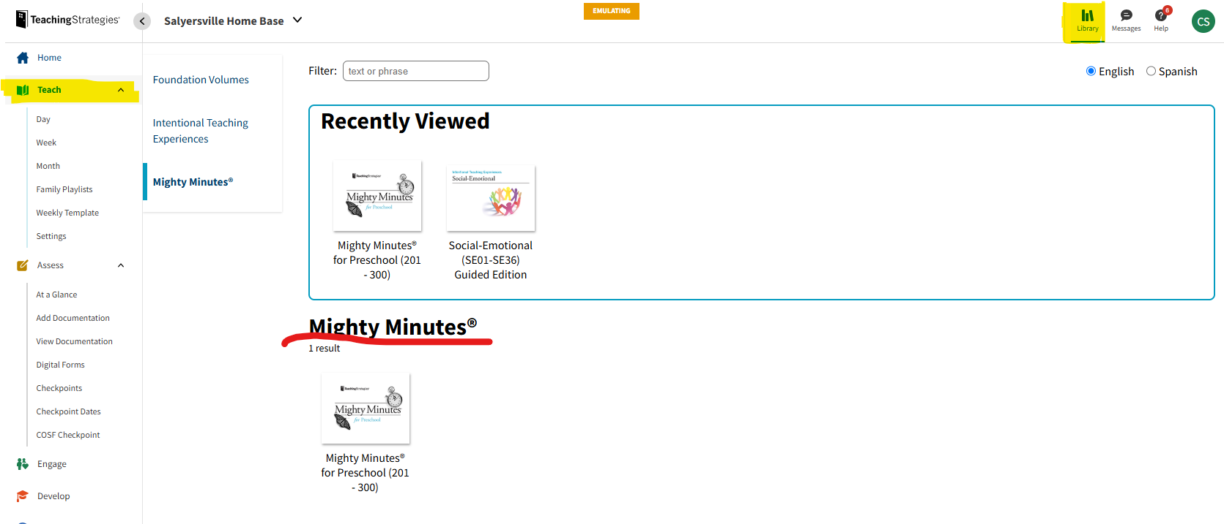

*Lesson plan instructions have been updated, please review these. They can be found on the Big Sandy headstart website under the Education section.

TSG
Login to SmartTeach and use the same classroom as last year. Update your class, archive children as needed and add new ones. *Check within your programs if you are unsure as to who archives children as well as inputting IEP’S, if it is not, you as the teacher.
If there is a child in your classroom that has an IEP, this information must be included on TSG as well as COPA. Staff will input this data under the child information on TSG. It should be the same date that is listed on COPA for the child beginning to receive services.
If a child gets an IEP in the middle of the school year, please log into your TSG account and update this information so that it pulls correctly when you are inputting observation notes for your assessments.

Below you will see step by step how to enter this information on TSG.

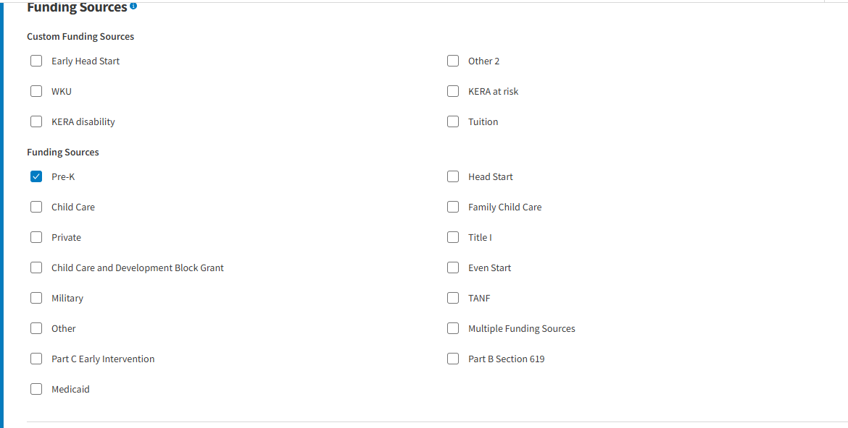

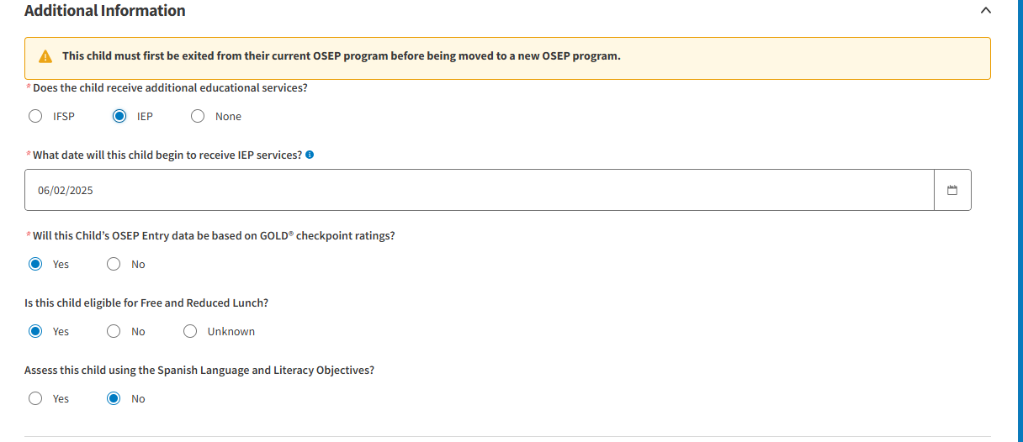

This will then open the self-care dimensions so that you can input those notes. This is for 1c1-1c4 on TSG and will appear for any child that has an IEP. These will only appear for a child if they have an IEP. It will look like below:

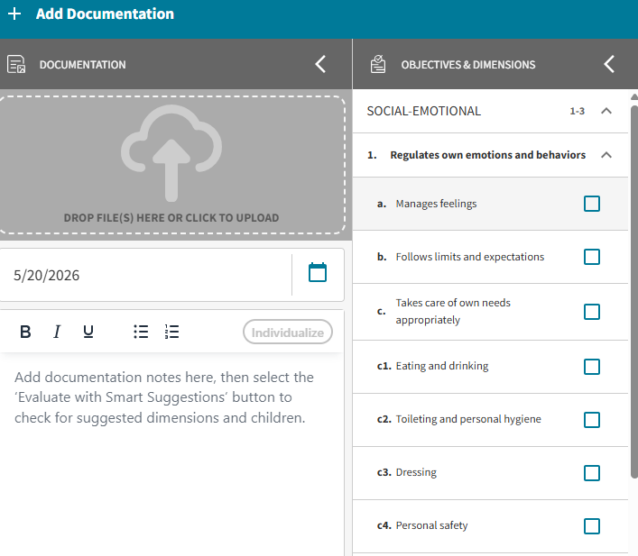

Observation Notes
You must have at least one note per dimension, per assessment period on TSG. You may continue adding notes for each objective as needed per child. The same note may apply to multiple dimensions. Notes should be taken daily on the children in your classroom to have accurate assessment data. You must have a copy of handwritten notes when grantee managers come to your room.
Observation notes can be used across multiple dimensions ie. K-I am going to make a pizza. T- How do we make a pizza? K- First we make the crust, then we add pepperoni and cheese, we put it in the oven for 5 minutes then we eat it. (8a, 9a, 9b)
Write an in-depth description of occurrence/observation in detail when entering the note on Teaching Strategies GOLD. Be specific in describing what the child is doing. Include: Who, What, When, and Where. Observation notes can be used across multiple dimensions ie. K-I am going to make a pizza. T- How do we make a pizza? K- First we make the crust, then we add pepperoni and cheese, we put it in the oven for 5 minutes then we eat it. (8a, 9a, 9b)
You can also take photos just add a note/detail on TSG with the photo when placing with objective.
Only one (1) GROUP NOTE each week (This is optional.)
A group note can be applied to more than one child and to one objective or multiple objectives. An example of a group note could be:
During gross motor play in the gym, the children played follow the leader (teacher). They hopped on one foot then the other on the black line. They jumped up and down in one place and hopped like a bunny. The children ran back and forth to each side of the gym before lining up back on the black line as instructed. The children then passed a ball back and forth to each other and were able to catch it. (2a-2d, 3a,3b,4,5,6)
*Be sure when you are completing assessments you are inputting a note for the dimensions that we do not use. This would just say, “Dimension does not apply”. These dimensions are: 15d, 18d, 18e, 19c, 20d, 20e, 20f, 22b, 22c.
Keep in mind that Grantee office managers will be asking to see your written notes. This will be a finding if they are not present with you in the classroom during the classroom observation.
Below are some examples of how to organize your notes:
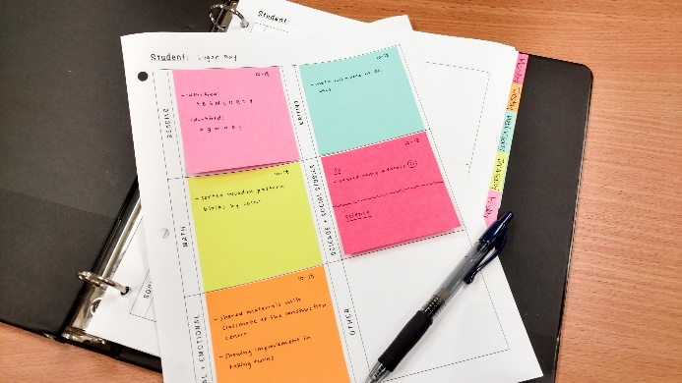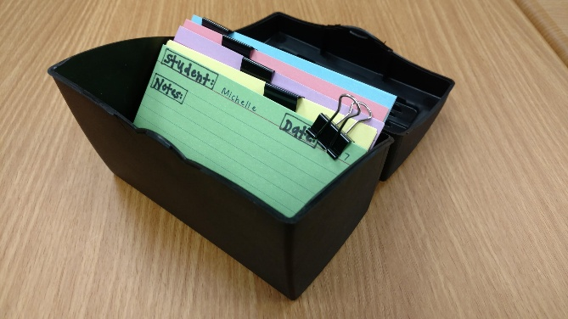
I have also provided some example sheets in the back of the handout that can be used for you to document anecdotal notes on for children.

Important Reminders regarding TSG:
- Be sure to print out your Class Profile report after completing the Assessments. You should be printing these out after the Fall, Winter and Spring Assessment. These will be checked when Grantee Staff complete a classroom observation.
- If a child enrolls after the date (below), he/she will need to be added to Teaching Strategies GOLD on the first day of the NEXT checkpoint season:
Fall: November 1st - This child will not need to be added to TSG until Dec 1st.

Winter: Feb 1st- This child will not need to be added to TSG until March 1st.

Spring: May 1st- This child will not need to be added to TSG until he/she returns the next fall season.

- Please be sure to complete your Interrater Reliability Certification. This will be completed under the Develop tab, with Quorum. Interrater Reliability is an online certification process that gives you an opportunity to evaluate sample child observation notes and compare your ratings with those of Teaching Strategies master raters. This is a requirement that must be completed before doing assessments on children. For New Staff, I will send you an email with your login information and explaining the process. For returning staff, as you know, I will send you an email reminding you of when your certification will be expiring so that you have time to complete the certification process. You recertify every three years.

- When looking at the Development Learning Report, you will want to be sure that each area has information provided for the parents. If there is no information added, the child does not have adequate assessment data. This means that preliminary levels have not been scored. The parents receive a copy of this report at the 2nd home visit and the final Parent Teacher conference.

Signatures- Record Review
When completing conferences, the parent must be the one that is signing on the conference form and/ or field trip. The parent signature must match the primary/secondary caregiver on COPA. If the parent that signed the form is not listed as either primary or secondary caregiver, it will be marked as a finding.

Conferences
Please make sure on the Education Home Visit/ Parent Teacher Conferences that you have checked/ marked a location on the form, as well as COPA. If the location for the Education Home Visit is anywhere other than Home then please give the reason. You should not be completing Education Home Visits nor Parent Teacher Conferences on field trips. Make sure that you have marked what type of visit that you are doing, if it is an Education Visit or Parent Teacher Conference. This should also be reflected to match what is on COPA.
- If you have a child that moves within the same center, example Johns Creek B to Johns Creek A, you will complete another Education Home Visit within the first 30 days.
- If you have a child that moves with the same program, for example a child moved from Allen A to Dace A, an Education Home Visit will be required to be completed within the first 30 days.
- If a child moves to another program, for example a child moves from Floyd to Johnson. An Education Home Visit will be required to be completed within the first 30 days.
** The required time for all Education Home Visits and Parent Teacher Conferences is a minimum of 30 minutes in duration.
** Teacher signature is required on conference forms as well as Parent signature.

Field Trips
We have updated the Field Trip Policy; It is now required that you take one field trip during Fall and one during Spring. When you are filling out the form be sure the education purpose of the trip is marked and easily identifiable.
Be sure that the parent has marked YES or NO on the field trip forms. Ensure that they have an emergency phone number listed and that they have signed. Be sure that the entire form is completely filled out.
Classroom Arrangement
The classroom must have at least 9 specific learning centers covering block building, dramatic play, experiences in art, fine motor/manipulatives, music/movement, science, computers/tablet/Smartboard, writing, and quiet book reading. There are 6 centers that must be “Stationary” meaning they are not moved during the day to different locations or only brought out during center time. These 6 centers are: Blocks, Art, Fine Motor, Library, Dramatic Play, and Science. In addition to the stationary learning centers, each classroom must have learning centers for music/movement, writing, and computers/tablet/Smartboard. These 3 additional centers can be stationary, but they can also be mobile centers that are only created during free play time. Make sure that centers are positioned away from regular foot traffic. Example: Entrance in the classroom should not pass through a learning center.
Separate the location of the learning centers that are “quiet” from the ones that are “noisy”. This can be done by having them on opposite sides of the classroom or by placing a “buffer” center between them. Centers should be viewed as quiet, noisy, or a buffer based on the information below:
• Quiet Centers: Library, Writing, Listening
• Buffer Centers: Computers, Science, Fine Motor, Math, Art
• Noisy Centers: Dramatic Play, Blocks, Musical Instruments
*Refer to Setting up the Physical Environment Policy (UPDATED)
Be sure to place appropriate labels on shelves, along with volunteer suggestions and CLASS questions. These can be found on BSACAP Head Start Website under FORMS then Education section.
Utilize “Required Classroom Display” document which identifies several items that must be posted inside or outside the classroom. We now require that pictures of children and families be posted within the classroom. (UPDATED on Website)
When creating your classroom schedule, please keep in mind requirements that are in place regarding time frames. We have updated some of these requirements and they can be found on the website in the Appropriate Knowledge document. Some of these changes are the length of circle time being no longer than 20 minutes. Storytime cannot be longer than 10 minutes if a stand-alone and if part of circle no longer than 20 minutes.

Parent Group
Make sure that your Grantee team manager has access to your Social Media/ Parent group so that they can monitor when your program has NTI days throughout the school year as well as parent communication, events, etc. You must use the same social media platform for your parent group that your director has chosen for your program. Share a summary of your lesson plan with parents each week in your group (ie. Facebook, Rooms, Parent Square). Be sure that you are utilizing this to communicate with your parents. Utilize this to post reminders about parent meetings and upcoming events that are happening with your classroom.

Fairness Chart
There must be a fairness chart located somewhere in the classroom identifying how children are appropriately transitioned between activities. It will likely identify children by a letter, number, shape, animal, etc that has been placed on their assigned table. The tables should be fairly rotated so that the “Blue table” does not always transition first or last.
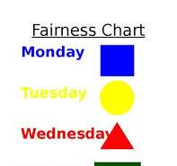

Other Policy Updates
An NTI Policy was created that covers what is required during Nontraditional Instruction days. Grantee staff will monitor your videos through your parent groups and provide feedback.

Integration of Health Safety Wellness in Curriculum as well as Promoting Physical Development was updated to reflect usage of wellness curriculum. The only programs allowed are Go Noodle, JAM or Danny Go which are required for 10 minutes.

The Daily Schedule policy was updated to reflect TPOT. There is now a requirement to the picture schedule where you will have an indication of passing of time. Example: pieces that can be flipped over, removed or a marker to denote current activity on schedule.

Child Guidance and Behavior policy was updated to reflect to state that classroom rules will be 5 or less.

Other important reminders:
- Please be sure that you complete your playground/gross motor checklist PRIOR to children entering the playground or gym. This should even be completed when you are having gross motor time in the gym.
- When going to the playground, be sure to take additional materials to the playground such as balls, hula hoops, stepping stones, etc.
- Be sure to complete the arrival- departure sheet upon children's arrival in the classroom. You will write the name of who picked up the child in the appropriate box.
- Be sure that you have all screenings and forms in the children’s folders. Any screening that is showing on COPA should be in the children’s folder. Likewise, any screening in the child’s folder should be on COPA.
- Be sure to take your first aid kit with you anytime that you leave the classroom.

