**2025-2026 Preservice/ In-Service**

**Lesson Plans**

All classrooms in your delegate program will be on the same schedule for the lesson plans. The lesson plan is set up in the way you need to complete it,please refer to the lesson plan instructions that are located on the BSACAP website.

A current copy of your lesson plan needs to be kept in a folder on your desk, this copy will show individualization. Post the most current lesson plan on the wall in a parent friendly area. **Children’s initials are not to be on this copy of the lesson plan.** The lesson plan with the child’s initials should be located on the lesson plan kept on your desk out of view of others. After each assessment, you need to print out the Class Profile Report found on TSG and place this in front of the lesson plan folder. This report will help you when individualizing your lesson plan. The Class Profile Report compares information about children’s skills, knowledge, and behaviors to widely held expectations for their age or class/grade during a particular checkpoint period.

**\*Be sure that each child is listed in the individualization.**

A “Lesson Plan Schedule” has been provided for all teaching staff. This schedule should be followed in the order listed and must be posted in a “parent-friendly” area of the room. Posting it on the wall behind your desk would NOT be a parent friendly area.

**Keep in mind Grantee staff will be checking your lesson plan during visits to ensure that you are completing all activities including gross motor activities listed on your lesson plan.**

**Fairness Chart**

There must be a fairness chart located somewhere in the classroom identifying how children are appropriately transitioned between activities. It will likely identify children by a letter, number, shape, animal, etc that has been placed on their assigned table. The tables should be fairly rotated so that the “Blue table” does not always transition first or last.

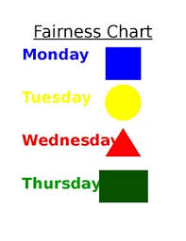

**Daily Schedule**

Please submit your classroom daily schedule to your Director/ Education Manager. Please submit your schedules by the end of the second week of school to your team manager, so the Grantee office will have a copy. If you have questions as to what the requirements are for the daily schedule, refer to the Daily Schedule policy on the Big Sandy Head Start website. The Director/ Education Manager will then submit those schedules to your Team Manager at the Grantee Office. If there are **any** changes in the schedule, you must **re-submit** it. Your Team Manager will go by the current schedule he/she has scheduling CLASS, as well as any other routine Classroom Observations.

**Conference Forms**

Please make sure on the Education Home Visit/ Parent Teacher Conferences that you have checked/ marked a location on the form, as well as COPA. If the location for the Education Home Visit is anywhere other than *Home* then please give the reason. You should not be completing Education Home Visits nor Parent Teacher Conferences on field trips. Make sure that you have marked what type of visit that you are doing if it is an Education Visit or Parent Teacher Conference. This should also be reflected to match on COPA.

* If you have a child that moves within the same center, you do not have to complete another Education Home Visit within the first 30 days. The child will remain on the regular timeline.
* If you have a child that moves with the same program, for example a child moved from Allen A to Dace A, an Education Home Visit will be required to be completed within the first 30 days.
* If a child moves to another program, for example a child moves from Floyd to Johnson. An Education Home Visit will be required to be completed within the first 30 days.

** The required time for all Education Home Visits and Parent Teacher Conferences is a minimum of 30 minutes in duration.

-**All information should match!**

**Setting Up the Physical Environment**

Please make sure you have all of the Required Classroom Display posted in your classroom. **Classroom Display Requirements** can be found on the BSACAP Head Start Website under **FORMS then the Education section.**

-Be sure to have your Volunteer Suggestions as well as the CLASS questions posted in your centers. These can be found on BSACAP Head Start Website under **FORMS then Education section.**

-Photos **and** names of children should be found in multiple places throughout the room. **Their pictures and names should be on their tables and cubbies at a minimum.**

-Be sure that you have writing materials for children to use throughout the learning centers. Refer to Setting Up Physical Environment Policy for more information.

**Behavior Management**

Each Program is required to utilize a Behavior Management System in each classroom. This can be a tree (made out of bulletin board paper) with birds (with children’s individual names on them) that start out each day on the branches of the tree. As you see them not making good choices they would fall off the tree limb. The bird’s would then come back off the ground onto the limb as you catch children following classroom rules, listening rules, using manners, etc.. ***Please remember that you will not leave a child at the bottom of the tree or if you have to move them down for any reason for a long period of time. These Behavior Management Systems are meant to be used in a positive manner. You will be able to find something positive to see in every child throughout the day. The main thing is to be consistent, (explaining the rules and your expectations to the children) and to use your Behavior Management System every day.***

Examples of Appropriate Behavior Management Systems

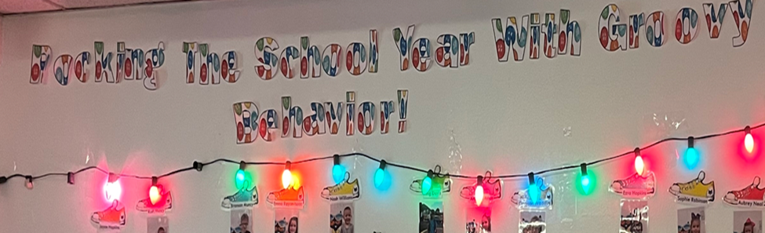

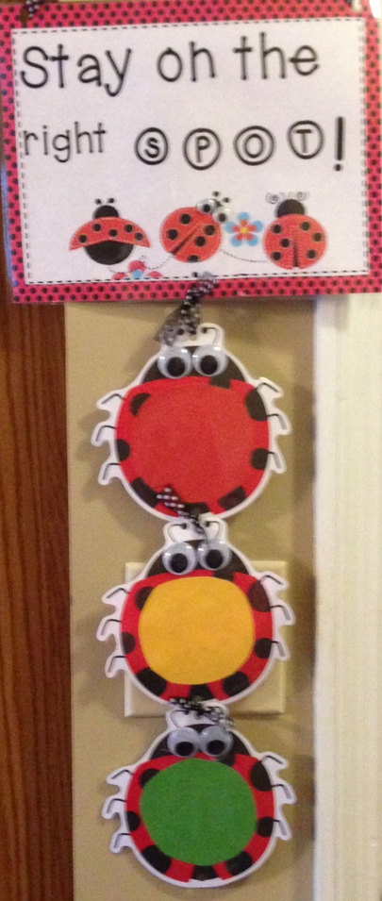

***Examples of what not to use:***

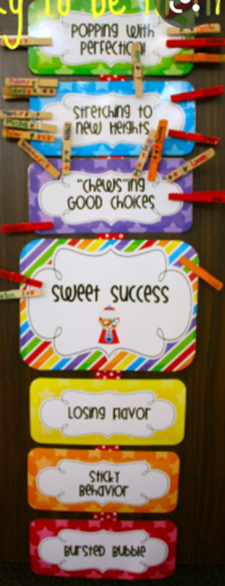 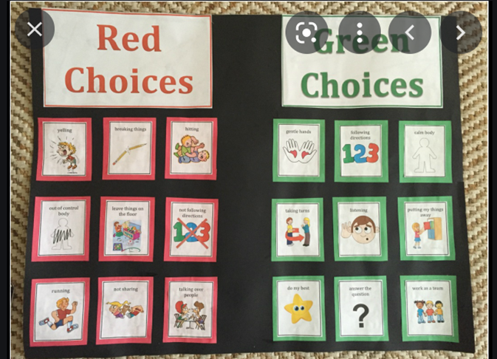

**TSG**

Login to SmartTeach and use the same classroom as last year. Update your class, archive children as needed and add new ones. *Check within your programs if you are unsure as to who archives children as well as inputting IEP’S, if it is not you as the teacher.

If there is a child in your classroom that has an IEP, this information has to be included on TSG as well as COPA. Staff will input this data under the child information on TSG. It should be the same date that is listed on COPA for the child beginning to receive services.

If a child gets an IEP in the middle of the school year, please log into your TSG account and update this information so that it pulls correctly when you are inputting observation notes for your assessments.

Below you will see step by step how to enter this information on TSG.

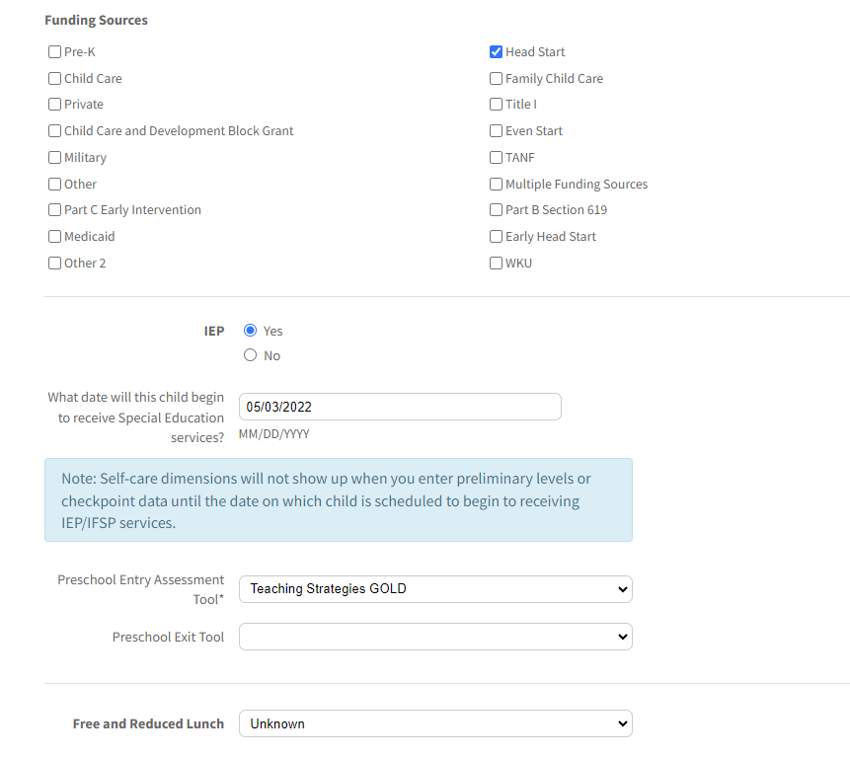

This will then open the self- care dimensions so that you can input those notes. This is for 1c1-1c4 on TSG and will appear for any child that has an IEP. **These will only appear for a child if they have an IEP.** It will look like below:

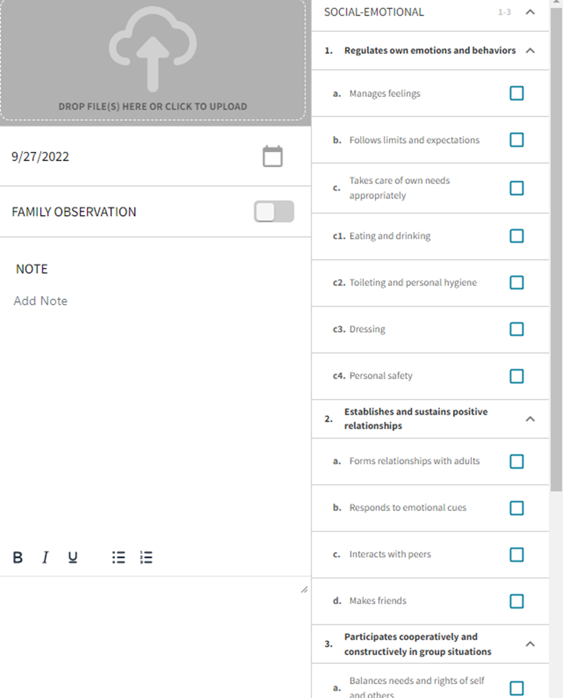

**Observation Notes**

You **must** have at least one note per dimension, per assessment period on TSG. You may continue adding notes for each objective as needed per child. The same note may apply to multiple dimensions.

Observation notes can be used across multiple dimensions ie. K-I am going to make a pizza. T- How do we make a pizza? K- First we make the crust, then we add pepperoni and cheese, we put it in the oven for 5 minutes then we eat it. ( 8a, 9a, 9b)

Write an in-depth description of occurrence/observation in detail when entering the note on Teaching Strategies GOLD. **Only one (1) GROUP NOTE each week( This is optional.)**

A group note can be applied to more than one child and to one objective or multiple objectives. An example of a group note could be:

During gross motor play in the gym, the children played follow the leader (teacher). They hopped on one foot then the other on the black line. They jumped up and down in one place and hopped like a bunny. The children ran back and forth to each side of the gym before lining up back on the black line as instructed. The children then passed a ball back and forth to each other and were able to catch it. ( 2a-2d, 3a,3b,4,5,6)

*Be sure when you are completing assessments you are inputting a note for the dimensions that we do not use. This would just say, “Dimension does not apply”. These dimensions are: 15d, 18d, 18e, 19c, 20d, 20e, 20f, 22b, 22c.

**Keep in mind that Grantee office managers will be asking to see your written notes. This will be a finding if they are not present with you in the classroom during the classroom observation.**

**Important Reminders regarding TSG:**

1. **Be sure to print out your Class Profile report after completing the Assessments. You should be printing these out after the Fall, Winter and Spring Assessment. These will be checked when Grantee Staff complete a classroom observation.**
2. **If a child enrolls after the date (below), he/she will need to be added to Teaching Strategies GOLD on the first day of the NEXT checkpoint season:**

**Fall: November 1-** **This child will not need to be added to TSG until Dec 1st.**

**Winter: Feb 1- This child will not need to be added to TSG until March 1st.**

**Spring: May1 - This child will not need to be added to TSG until he/she returns next fall season.**

1. **Please be sure to complete your Interrater Reliability Certification.** This will be completed under the Develop tab, with Quorum. Interrater Reliability is an online certification process that gives you an opportunity to evaluate sample child observation notes and compare your ratings with those of Teaching Strategies master raters. **This is a requirement that must be completed before doing assessments on children.** For New Staff, I will send you an email with your login information and explaining the process. For returning staff, as you know, I will send you an email reminding you of when your certification will be expiring so that you have time to complete the certification process. You recertify every three years.
2. When looking at the **Development Learning Report**, you will want to be sure that each area has information provided for the parent. If there is no information added, the child does not have adequate assessment data. This means that preliminary levels have not been scored. The parents receive a copy of this report at the 2nd home visit and the final Parent Teacher conference.

**Parent Group**

Make sure that your Grantee team manager has access to your Social Media/ Parent group so that they can monitor when your program has NTI days throughout the school year as well as parent communication, events, etc. You must use the same social media platform for your parent group that your director has chosen for your program. Share a summary of your lesson plan with parents each week in your group (ie. Facebook, Rooms, Parent Square). Be sure that you are utilizing this to communicate with your parents. Utilize this to post reminders about parent meetings and upcoming events that are happening with your classroom.

**Other important reminders:**

* Please be sure that you complete your playground/gross motor checklist PRIOR to children entering the playground or gym. This should even be completed when you are having gross motor time in the gym.
* When going to the playground, be sure to take additional materials to the playground such as balls, hula hoops, stepping stones, etc.
* Be sure to complete the arrival- departure sheet upon children's arrival in the classroom. You will write the name of who picked the child in the appropriate box.
* Be sure that you have all screenings and forms in the child's folders. Any screening that is showing on COPA should be in the child’s folder. Likewise, any screening in the child’s folder should be on COPA.
* The Teacher Questionnaire should not be completed prior to the 14 day timeline.
* Be sure that the parent has marked YES or NO on the field trip forms. That they have an emergency phone number listed and that they have signed.
* When sending family projects home for completion, please do not refer to these as homework. Also do not give prizes or rewards to those children that bring these projects back completed. These are to only be counted 1 hour maximum each week.